# Graph

A graph can be defined as group of vertices and edges that are used to connect these vertices. A graph can be seen as a cyclic tree, where the vertices (Nodes) maintain any complex relationship among them instead of having parent child relationship.

## Definition

A graph G can be defined as an ordered set G(V, E) where V(G) represents the set of vertices and E(G) represents the set of edges which are used to connect these vertices.

A Graph G(V, E) with 5 vertices (A, B, C, D, E) and six edges ((A,B), (B,C), (C,E), (E,D), (D,B), (D,A)) is shown in the following figure.

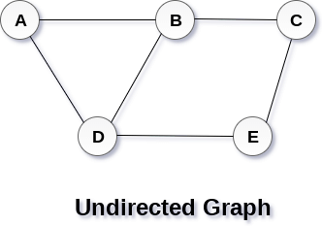

classification of graph

1. Directed Graph

2. Undirected Graph

**Directed Graph**

A directed graph is graph, i.e., a set of objects (called vertices or nodes) that are connected together, where all the edges are directed from one vertex to another. A directed graph is sometimes called a digraph or a directed network.

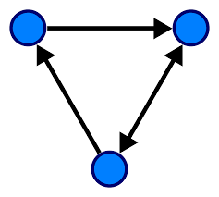 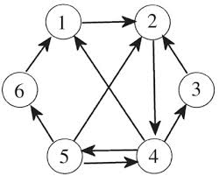

**Undirected Graph**

An undirected graph is graph, i.e., a set of objects (called vertices or nodes) that are connected together, where all the edges are bidirectional. An undirected graph is sometimes called an undirected network. In contrast, a graph where the edges point in a

direction is called a directed graph.

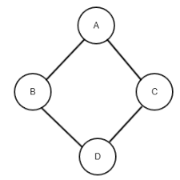 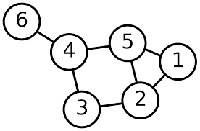

**Graph Terminology**

– Vertex

– edge

– path

– Adjacency

# Graph Representation

By Graph representation, we simply mean the technique which is to be used in order to store some graph into the computer's memory.

There are two ways to store Graph into the computer's memory. In this part of this tutorial, we discuss each one of them in detail.

### 1. Sequential Representation

#### 2. Linked Representation

## **Sequential Representation**

In sequential representation, we use adjacency matrix to store the mapping represented by vertices and edges. In adjacency matrix, the rows and columns are represented by the graph vertices. A graph having n vertices, will have a dimension n x n.

An entry Mij in the adjacency matrix representation of an undirected graph G will be 1 if there exists an edge between Vi and Vj.

An undirected graph and its adjacency matrix representation is shown in the following figure.

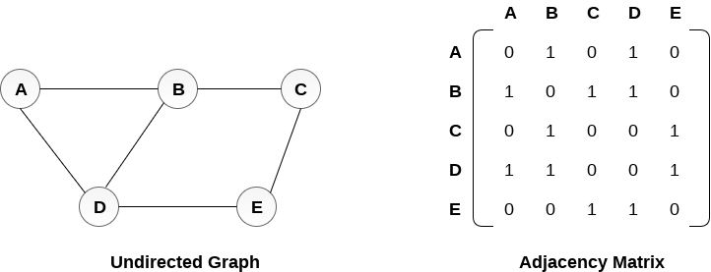

in the above figure, we can see the mapping among the vertices (A, B, C, D, E) is represented by using the adjacency matrix which is also shown in the figure.

There exists different adjacency matrices for the directed and undirected graph. In directed graph, an entry Aij will be 1 only when there is an edge directed from Vi to Vj.

A directed graph and its adjacency matrix representation is shown in the following figure.

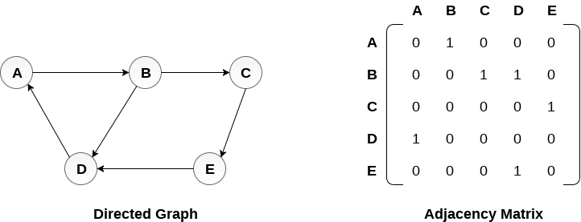

Representation of weighted directed graph is different. Instead of filling the entry by 1, the Non- zero entries of the adjacency matrix are represented by the weight of respective edges.

The weighted directed graph along with the adjacency matrix representation is shown in the following figure.

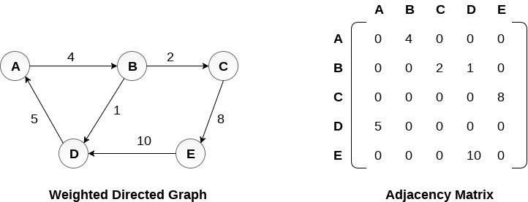

## **Linked Representation**

In the linked representation, an adjacency list is used to store the Graph into the computer's memory.

Consider the undirected graph shown in the following figure and check the adjacency list representation.

An adjacency list is maintained for each node present in the graph which stores the node value and a pointer to the next adjacent node to the respective node. If all the adjacent nodes are traversed then store the NULL in the pointer field of last node of the list. The sum of the lengths of adjacency lists is equal to the twice of the number of edges present in an undirected graph.

Consider the directed graph shown in the following figure and check the adjacency list representation of the graph.

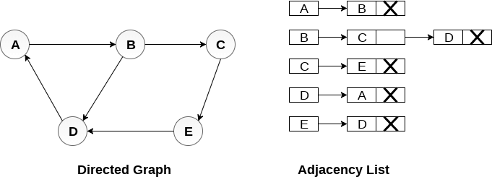

In a directed graph, the sum of lengths of all the adjacency lists is equal to the number of edges present in the graph.

In the case of weighted directed graph, each node contains an extra field that is called the weight of the node. The adjacency list representation of a directed

graph is shown in the following figure.

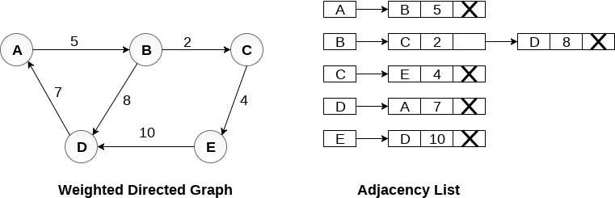

https://www.javatpoint.com/graph-representation